**PL/SQL programming**

**Exercise 1: Control Structures**

**Scenario 1 :Customers over 60**

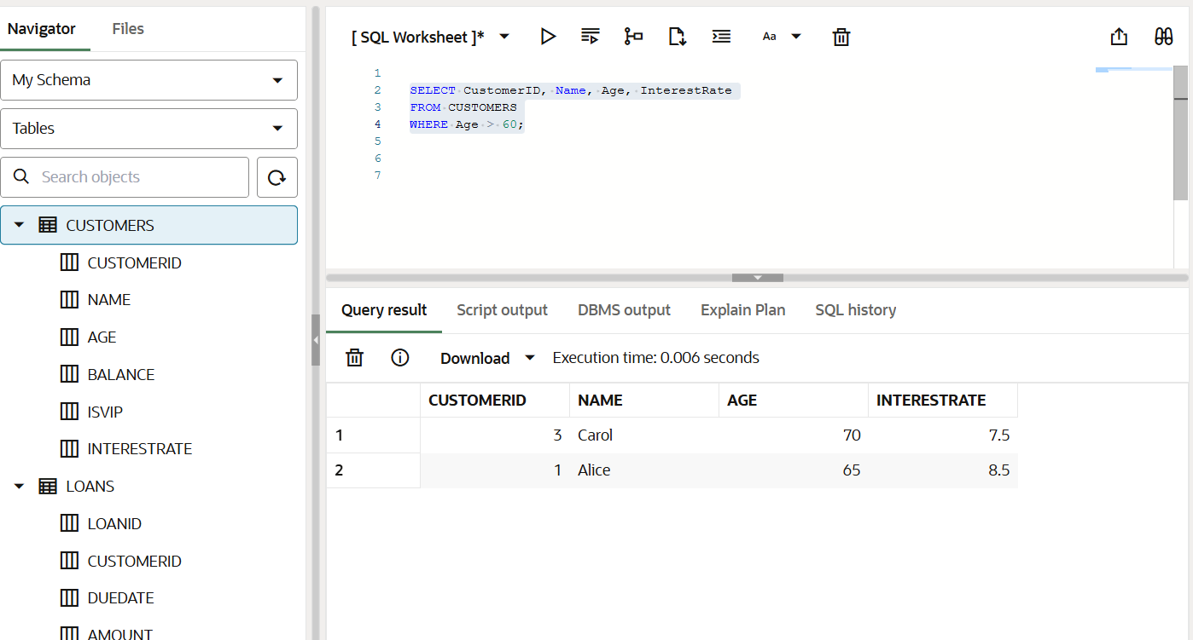

**Scenario 2 Customers with Balance > 10000**

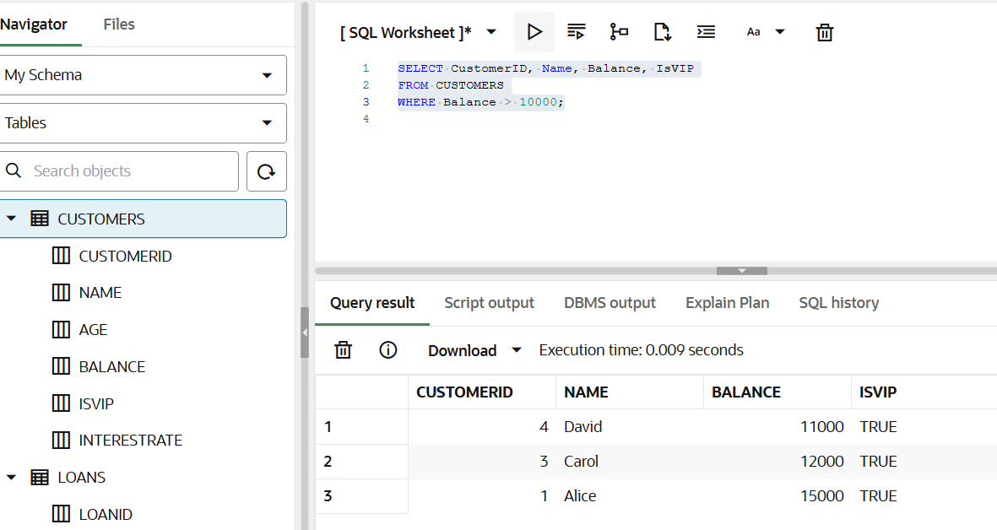

**Scenario 3: Loans due in the next 30 days → Reminders**

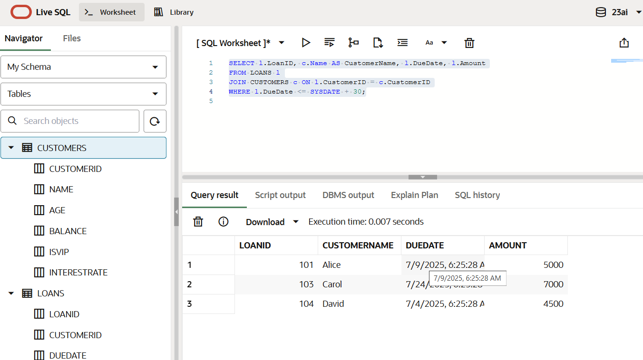

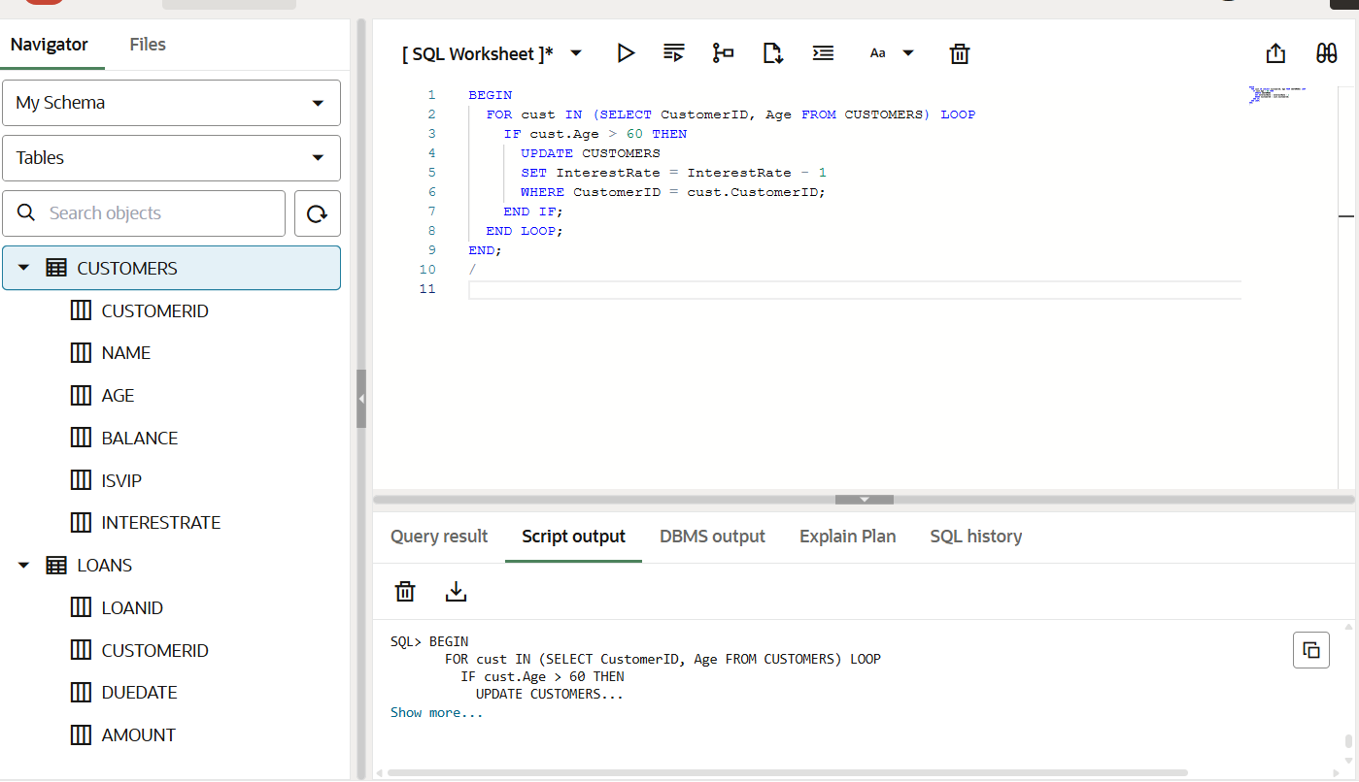

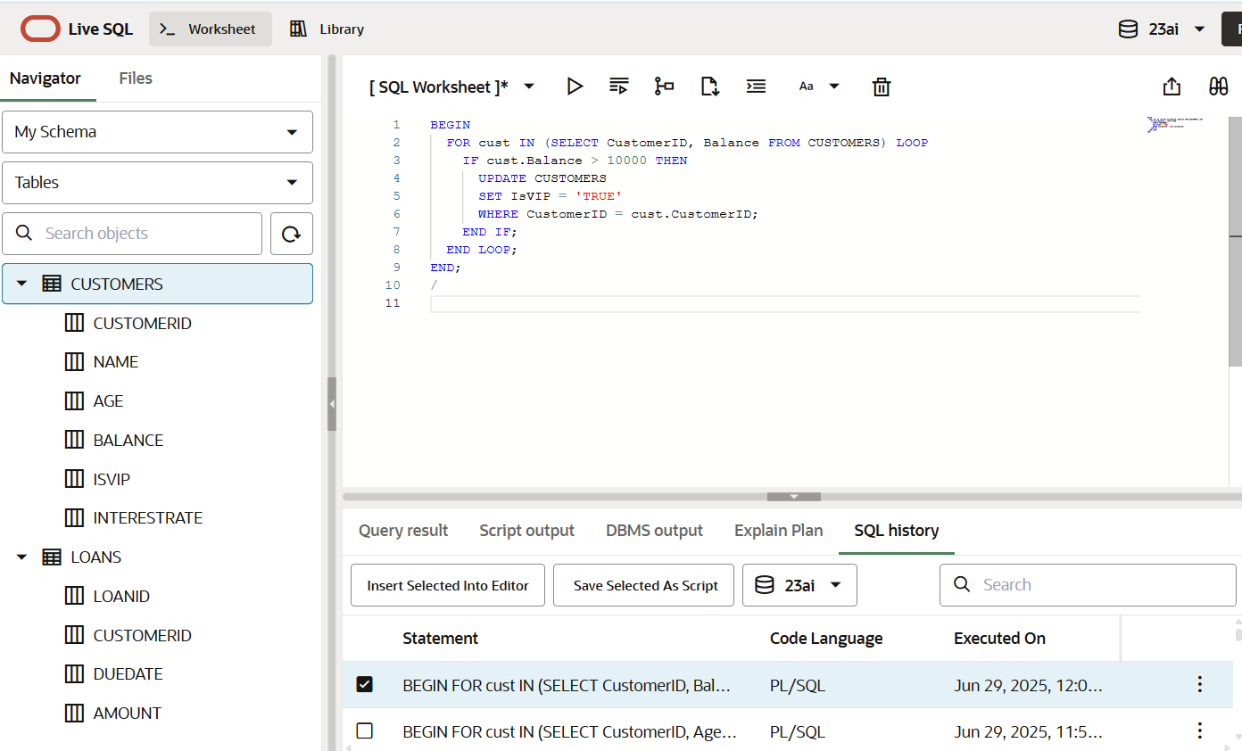

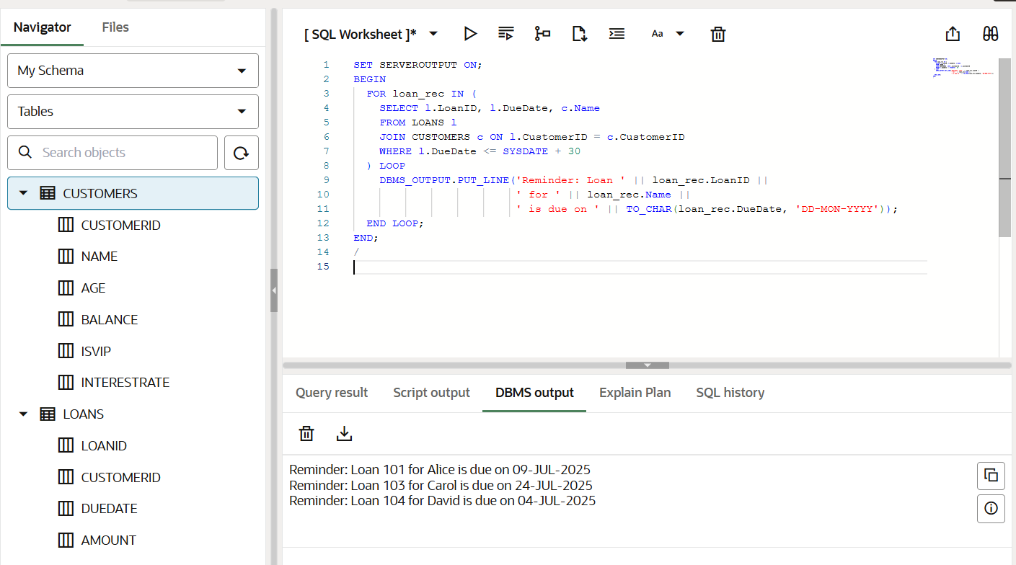

**Output**

Reminder: Loan 101 for Alice is due on 09-JUL-2025

Reminder: Loan 103 for Carol is due on 24-JUL-2025

Reminder: Loan 104 for David is due on 04-JUL-2025

**Exercise 3: Stored Procedures**

**Scenario 1: ProcessMonthlyInterest Procedure**

CREATE OR REPLACE PROCEDURE ProcessMonthlyInterest IS

BEGIN

UPDATE SAVINGS_ACCOUNTS

SET Balance = Balance + (Balance * 0.01);

END;

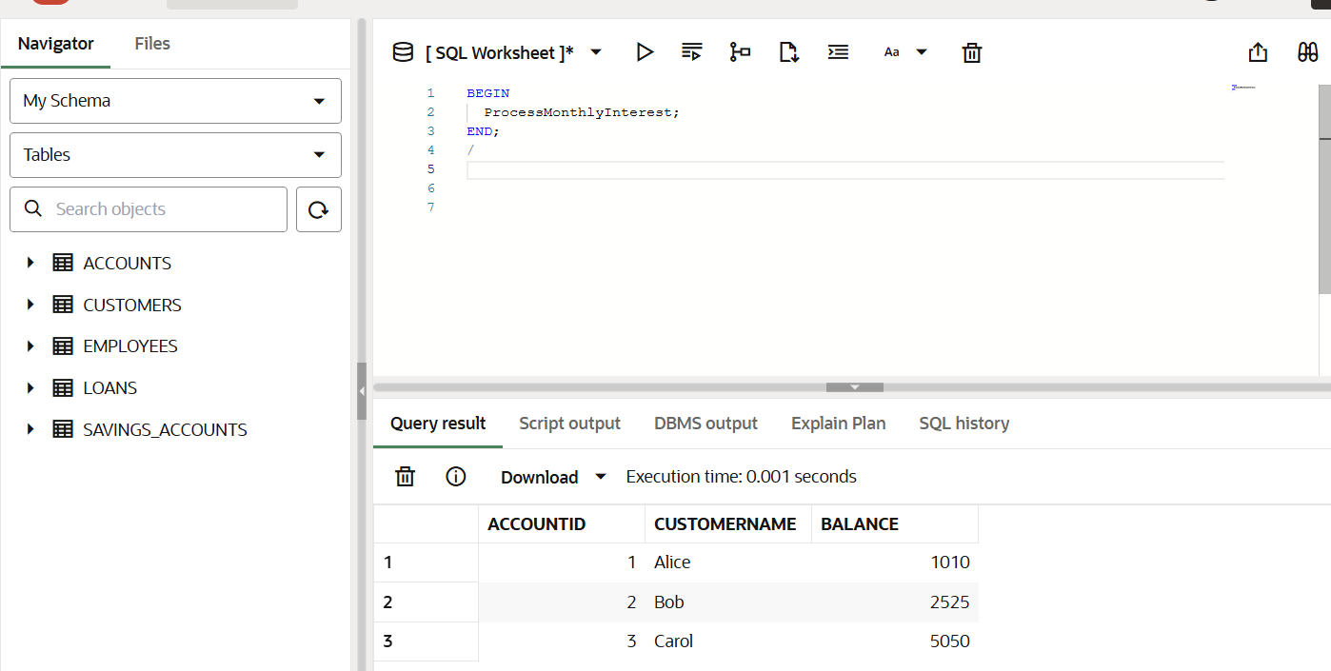

**Scenario 2: UpdateEmployeeBonus Procedure**

CREATE OR REPLACE PROCEDURE UpdateEmployeeBonus (

p_Department IN VARCHAR2,

p_BonusPercent IN NUMBER

) IS

BEGIN

UPDATE EMPLOYEES

SET Salary = Salary + (Salary * p_BonusPercent / 100)

WHERE Department = p_Department;

END;

/

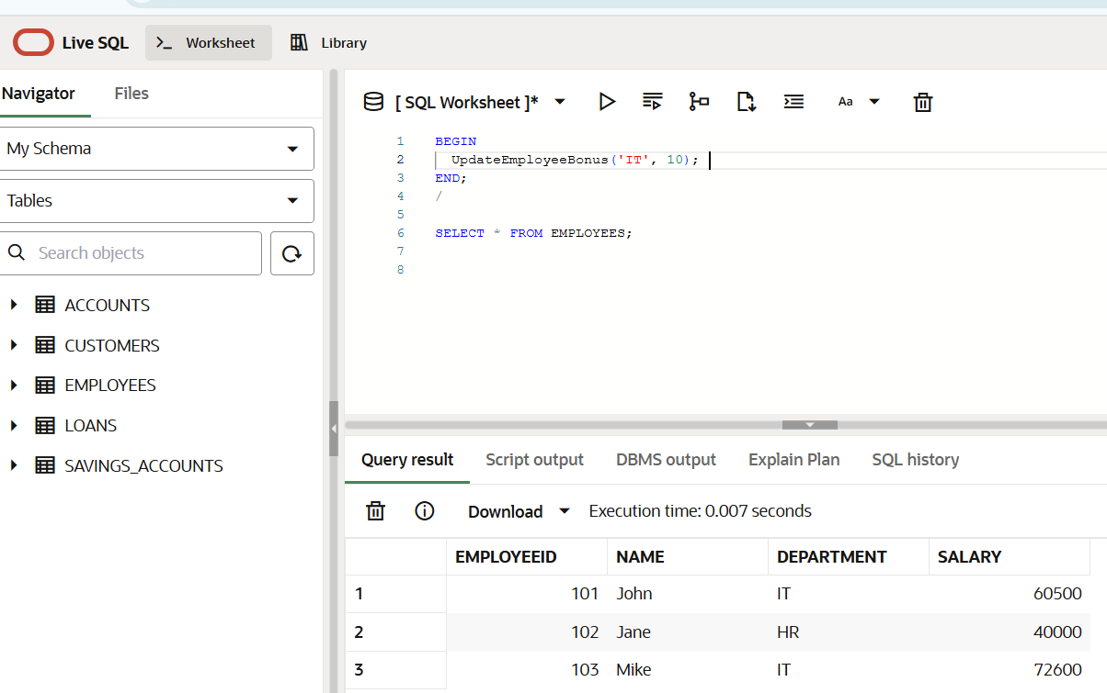

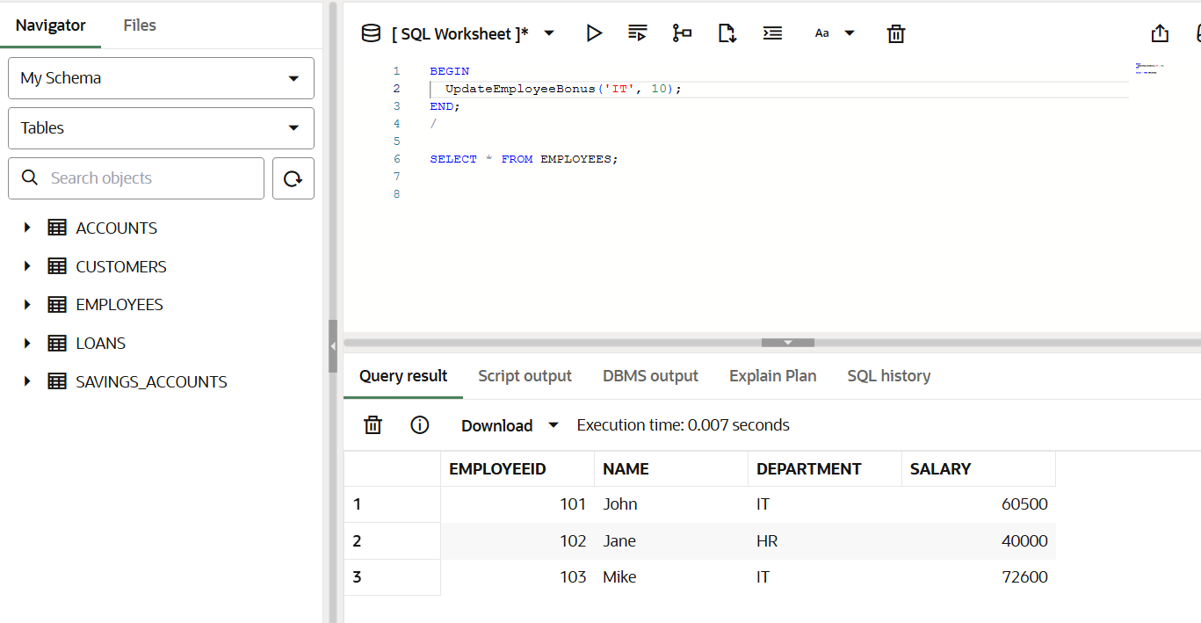

**Scenario 3: TransferFunds Procedure**

CREATE OR REPLACE PROCEDURE TransferFunds (

p_FromAccount IN NUMBER,

p_ToAccount IN NUMBER,

p_Amount IN NUMBER

) IS

v_FromBalance NUMBER;

BEGIN

SELECT Balance INTO v_FromBalance FROM ACCOUNTS WHERE AccountID = p_FromAccount;

IF v_FromBalance < p_Amount THEN

RAISE_APPLICATION_ERROR(-20001, 'Insufficient funds in source account');

END IF;

UPDATE ACCOUNTS

SET Balance = Balance - p_Amount

WHERE AccountID = p_FromAccount;

UPDATE ACCOUNTS SET Balance = Balance + p_AmountWHERE AccountID = p_ToAccount; END;



**Output**

